CPE301 – SPRING 2019

Design Assignment 4A

Student Name: Rocky Yasuaki Gonzalez

Student #: 5003229733

Student Email: gonzar14@unlv.nevada.edu

Primary Github address: https://github.com/rockyg1995/ihswppdar.git

Directory: C:\Users\rocky\Documents\CpE 301+L - Embedded Systems Design\CpE

301\Repository\DesignAssignments\DA4A

Submit the following for all Labs:

1. In the document, for each task submit the modified or included code (only) with highlights and justifications of the modifications. Also, include the comments.
2. Use the previously create a Github repository with a random name (no CPE/301, Lastname, Firstname). Place all labs under the root folder ESD301/DA, sub-folder named LABXX, with one document and one video link file for each lab, place modified asm/c files named as LabXX-TYY.asm/c.
3. If multiple asm/c files or other libraries are used, create a folder LabXX-TYY and place these files inside the folder.
4. The folder should have a) Word document (see template), b) source code file(s) and other include files, c) text file with youtube video links (see template).

1. **COMPONENTS LIST AND CONNECTION BLOCK DIAGRAM w/ PINS**

Atmega328PB Xplained Mini

Micro USB Cable (Power Supply)

Breadboard

x2 100nF Capacitors

10uH Inductor

Wire Connectors

DC Motor

L293

Pushbutton Switch

1k resistor

1k Potentiometer

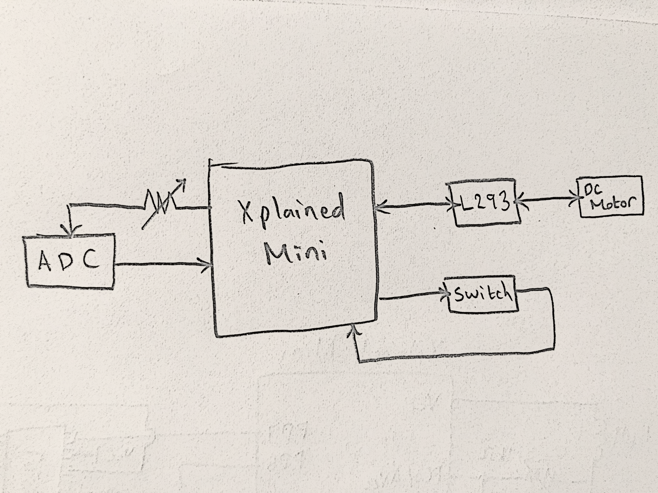

*Figure 1 – Block Diagram*

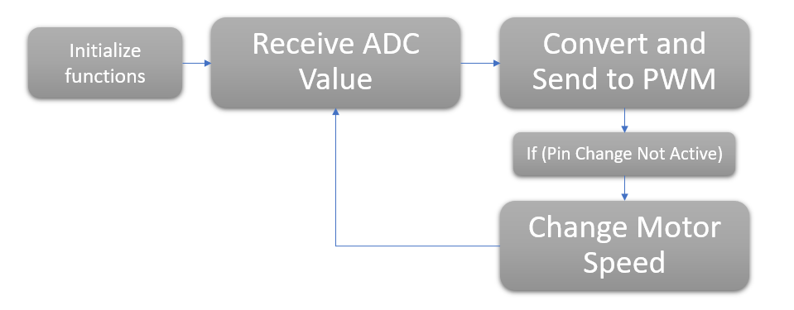

*Figure 2 – Flow Chart for Coding Algorithm*

1. **INITIAL/DEVELOPED CODE OF TASK**

/*

* DA4A.c

*

* Created: 4/13/2019 3:36:09 PM

* Author: RYG95

*/

#define *F_CPU* 16000000UL // Frequency of Xplained Mini (16MHz)

#include <avr/io.h> // Standard AVR Library

#include <stdio.h> // AVR library containing printf functions

#include <avr/interrupt.h> // AVR library containing interrupt functions

#include <util/delay.h> // AVR library containing _delay_ms() function

#define BAUDRATE 9600 // Baudrate in Bits per second (bps)

#define BAUD_PRESCALLER ((*F_CPU* / (BAUDRATE * 16UL)) - 1) // Baudrate UBRR0H:UBRR0L

//Declaration of our functions

void Timer0_init(void); // Function to Initialize Timer1 properties

void adc_init(void); // Function to initialize Analog to Digital Converter

void read_adc(void); // Function to read temperature received from ADC

void USART_init(void); // Function to initialize USART

unsigned char USART_receive(void); // Function to receive Serial data from UDR0

void USART_send(unsigned char data); // Function to send individual char into UDR0

void USART_putstring(char* StringPtr); // Function to break string into chars and send

volatile float adc_val; // Stores ADC Value representing Analog Voltage

char outs[20]; // 'outs[]' used to store integer and float

// values into array of chars size 20

int main(void) {

DDRC = 0x00; // All of PC7:0 Inputs (PC0 Input ADC, PC1 Switch)

PORTC = (1<<DDC1); // Set pull-up for PC1

DDRD |= (1 << DDD6)|(1 << DDD7); // PD6 and PD7 are Outputs (DC Motor)

PORTD |= (1 << DDD6)|(0 << DDD7); // PD6 is HIGH, PD7 is LOW (DC Motor)

// PCMSK1 = (1<<PCINT9); // Set Pin Change Interrupt on PC1

// PCICR |= (1<<PCIE1);

sei(); // Enable Global Interrupts

Timer0_init(); // Call the Timer0/PWM initialization code

adc_init(); // Call the ADC initialization code

USART_init(); // Call the USART initialization code

USART_putstring("Connected!\r\n"); // Pass 'Connected!' to send serial of chars

*_delay_ms*(125); // Wait a bit

while (1) { // Infinite loop

read_adc(); // Read value of ADC Value

*snprintf*(outs,sizeof(outs),"%3f", adc_val);// Stores 'adc_temp' in 'outs'

USART_putstring(outs); // Pass 'outs' to function to send chars

*_delay_ms*(250);

if (adc_val >= 242) { // If 'adc_val >= 242'...

OCR0A = 242; // Cap Duty Cycle at 95%

USART_putstring(", 95%\r\n");

} else if ((adc_val<242) & (adc_val >= 5)) { // Else, if ‘5<adc_val<242’

OCR0A = adc_val; // Duty Cycle ‘%’ = adc_val

USART_putstring(", ");

adc_val = (adc_val/255)*100;

*snprintf*(outs,sizeof(outs),"%3f", adc_val);

USART_putstring(outs);

USART_putstring("%\r\n");

} else if (adc_val < 5) { // Else, if ' adc_val < 5'

OCR0A = adc_val; // Drop Duty Cycle to 0%

USART_putstring(", 0%\r\n");

}

}

return 0;

}

//-----------------------------------------------------------------------

/*

ISR(PCINT1_vect) { // Pin Change Interrupt to toggle DC MOTOR

_delay_ms(250); // Prevent debounce error

while (PINC1 != 0); // Stuck in loop until switch let go

_delay_ms(250); // Prevent debounce error

PORTD ^= (1 << DDD7); // Toggle PD7 (DC Motor) Break/Spin

};

*/

//-----------------------------------------------------------------------

void Timer0_init(void) { // Initialize Timer0 properties

TCCR0A |= (1 << COM0A1); // Set non-inverting mode

TCCR0A |= (1 << WGM01) | (1 << WGM00); // Set fast PWM Mode

TCCR0B |= (1 << CS02); // Set prescaler to 256 and starts PWM

}

//-----------------------------------------------------------------------

void USART_init(void) { // Initialize USART properties

UBRR0H = (*uint8_t*)(BAUD_PRESCALLER >> 8); // Store Upper Baudrate in UBRR0H

UBRR0L = (*uint8_t*)(BAUD_PRESCALLER); // Store Lower Baudrate in UBRR0L

UCSR0B = (1 << RXEN0) | (1 << TXEN0); // Enable Receiver and Enable Transmitter

UCSR0C = (3 << UCSZ00); // Set UCSZ02:1 as 8-bit character data

}

unsigned char USART_receive(void) { // Function to receive ASCII from UDR0

while (!(UCSR0A & (1 << RXC0))); // Keep Checking RXC0 is 'High' to break

return UDR0; // Return received serial into char data

}

void USART_send(unsigned char data) { // Transmit ASCII value into UDR0

while (!(UCSR0A & (1 << UDRE0))); // Check UDRE0 data 'High' to break loop

UDR0 = data; // Store unsigned char serial into UDR0

}

void USART_putstring(char* StringPtr) { // Function to break string into chars

while (*StringPtr != 0x00) { // Keep Looping until String Completed

USART_send(*StringPtr); // Send string

StringPtr++; // Increment to next char array location

}

}

//-----------------------------------------------------------------------

void adc_init(void) {

DIDR0 = 0x3F; // Disable Digital Input

ADMUX = (0<<REFS1)|(1<<REFS0)| // Reference Select Bits, AVcc Ext cap at AREF

(0<<ADLAR)| // ADC Left Adjust Result for 10-bit result

(0<<MUX3)|(0<<MUX2)|(0<<MUX1)|(0<<MUX0);// Analog Channel Selection Bits 'ADC0'

ADCSRA = (1<<ADEN)| // ADC Enable

(0<<ADSC)| // ADC Start Conversion

(0<<ADATE)| // ADC Auto Trigger Enable

(0<<ADIF)| // ADC Interrupt Flag

(0<<ADIE)| // ADC Interrupt Enable

(1<<ADPS2)|(0<<ADPS1)|(1<<ADPS0); // ADC Prescaler Select Bits '32'

}

void read_adc(void) {

unsigned char i = 4; // Set 'i' for iterations

adc_val = 0; // set float 'adc_val'

while (i--) { // Decrement 'i' until 4 samples take

ADCSRA |= (1<<ADSC); // If ADSC is high (ADC Start Conversion)...

while (ADCSRA & (1<<ADSC)); // Start the ADC Conversion

adc_val += ADC; // Store the analog value on of current adc_val

*_delay_ms*(50); // delay 50ms for sampling

}

adc_val = (adc_val/4); // Average of 4 samples taken into adc_val

adc_val = (adc_val - 512)/2; // Lets 10-bit Analog voltage become 8-bit value

}

1. **SCHEMATICS**

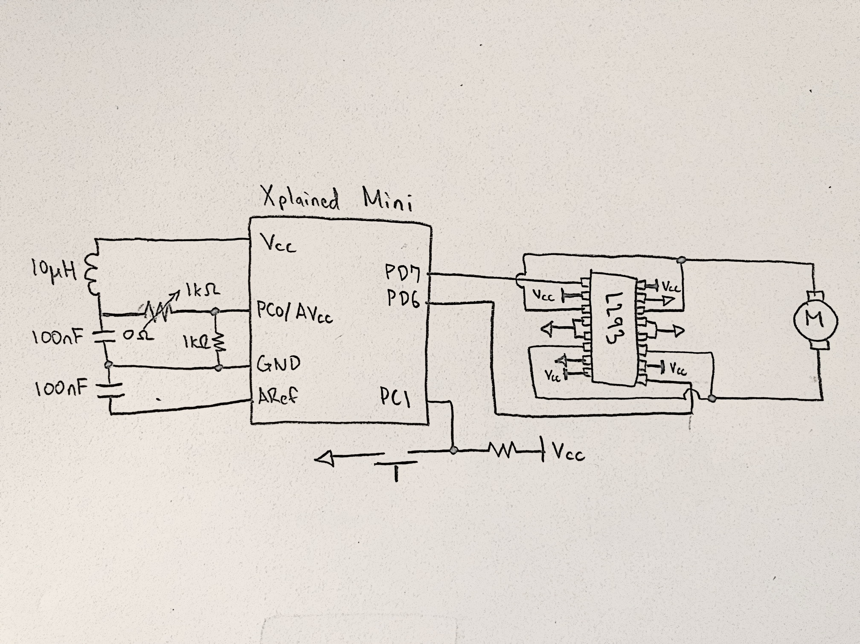

*Figure 3 – Schematic of DC Motor and Potentiometer ADC*

1. **SCREENSHOTS OF EACH TASK OUTPUT (ATMEL STUDIO OUTPUT)**

Since the Atmega328P/PB Xplained Mini has a built in AVR RX/TX module, we can send our serial data into a terminal which is able to display the temperature reading of ADC when connected to a temperature sensor (LM35) sending analog data into ADC channel 5. The output is portrayed in *Figure 4*:

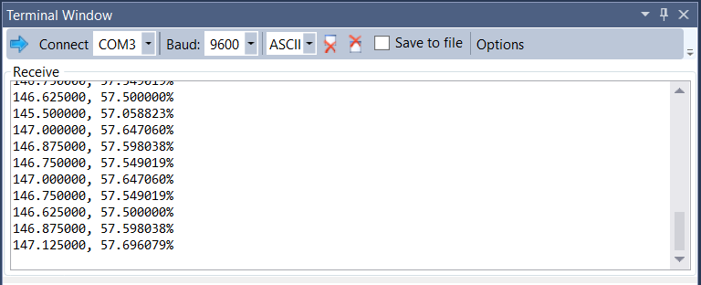

*Figure 4 – Output Terminal of Serial Data*

1. **SCREENSHOT OF EACH DEMO (BOARD SETUP)**

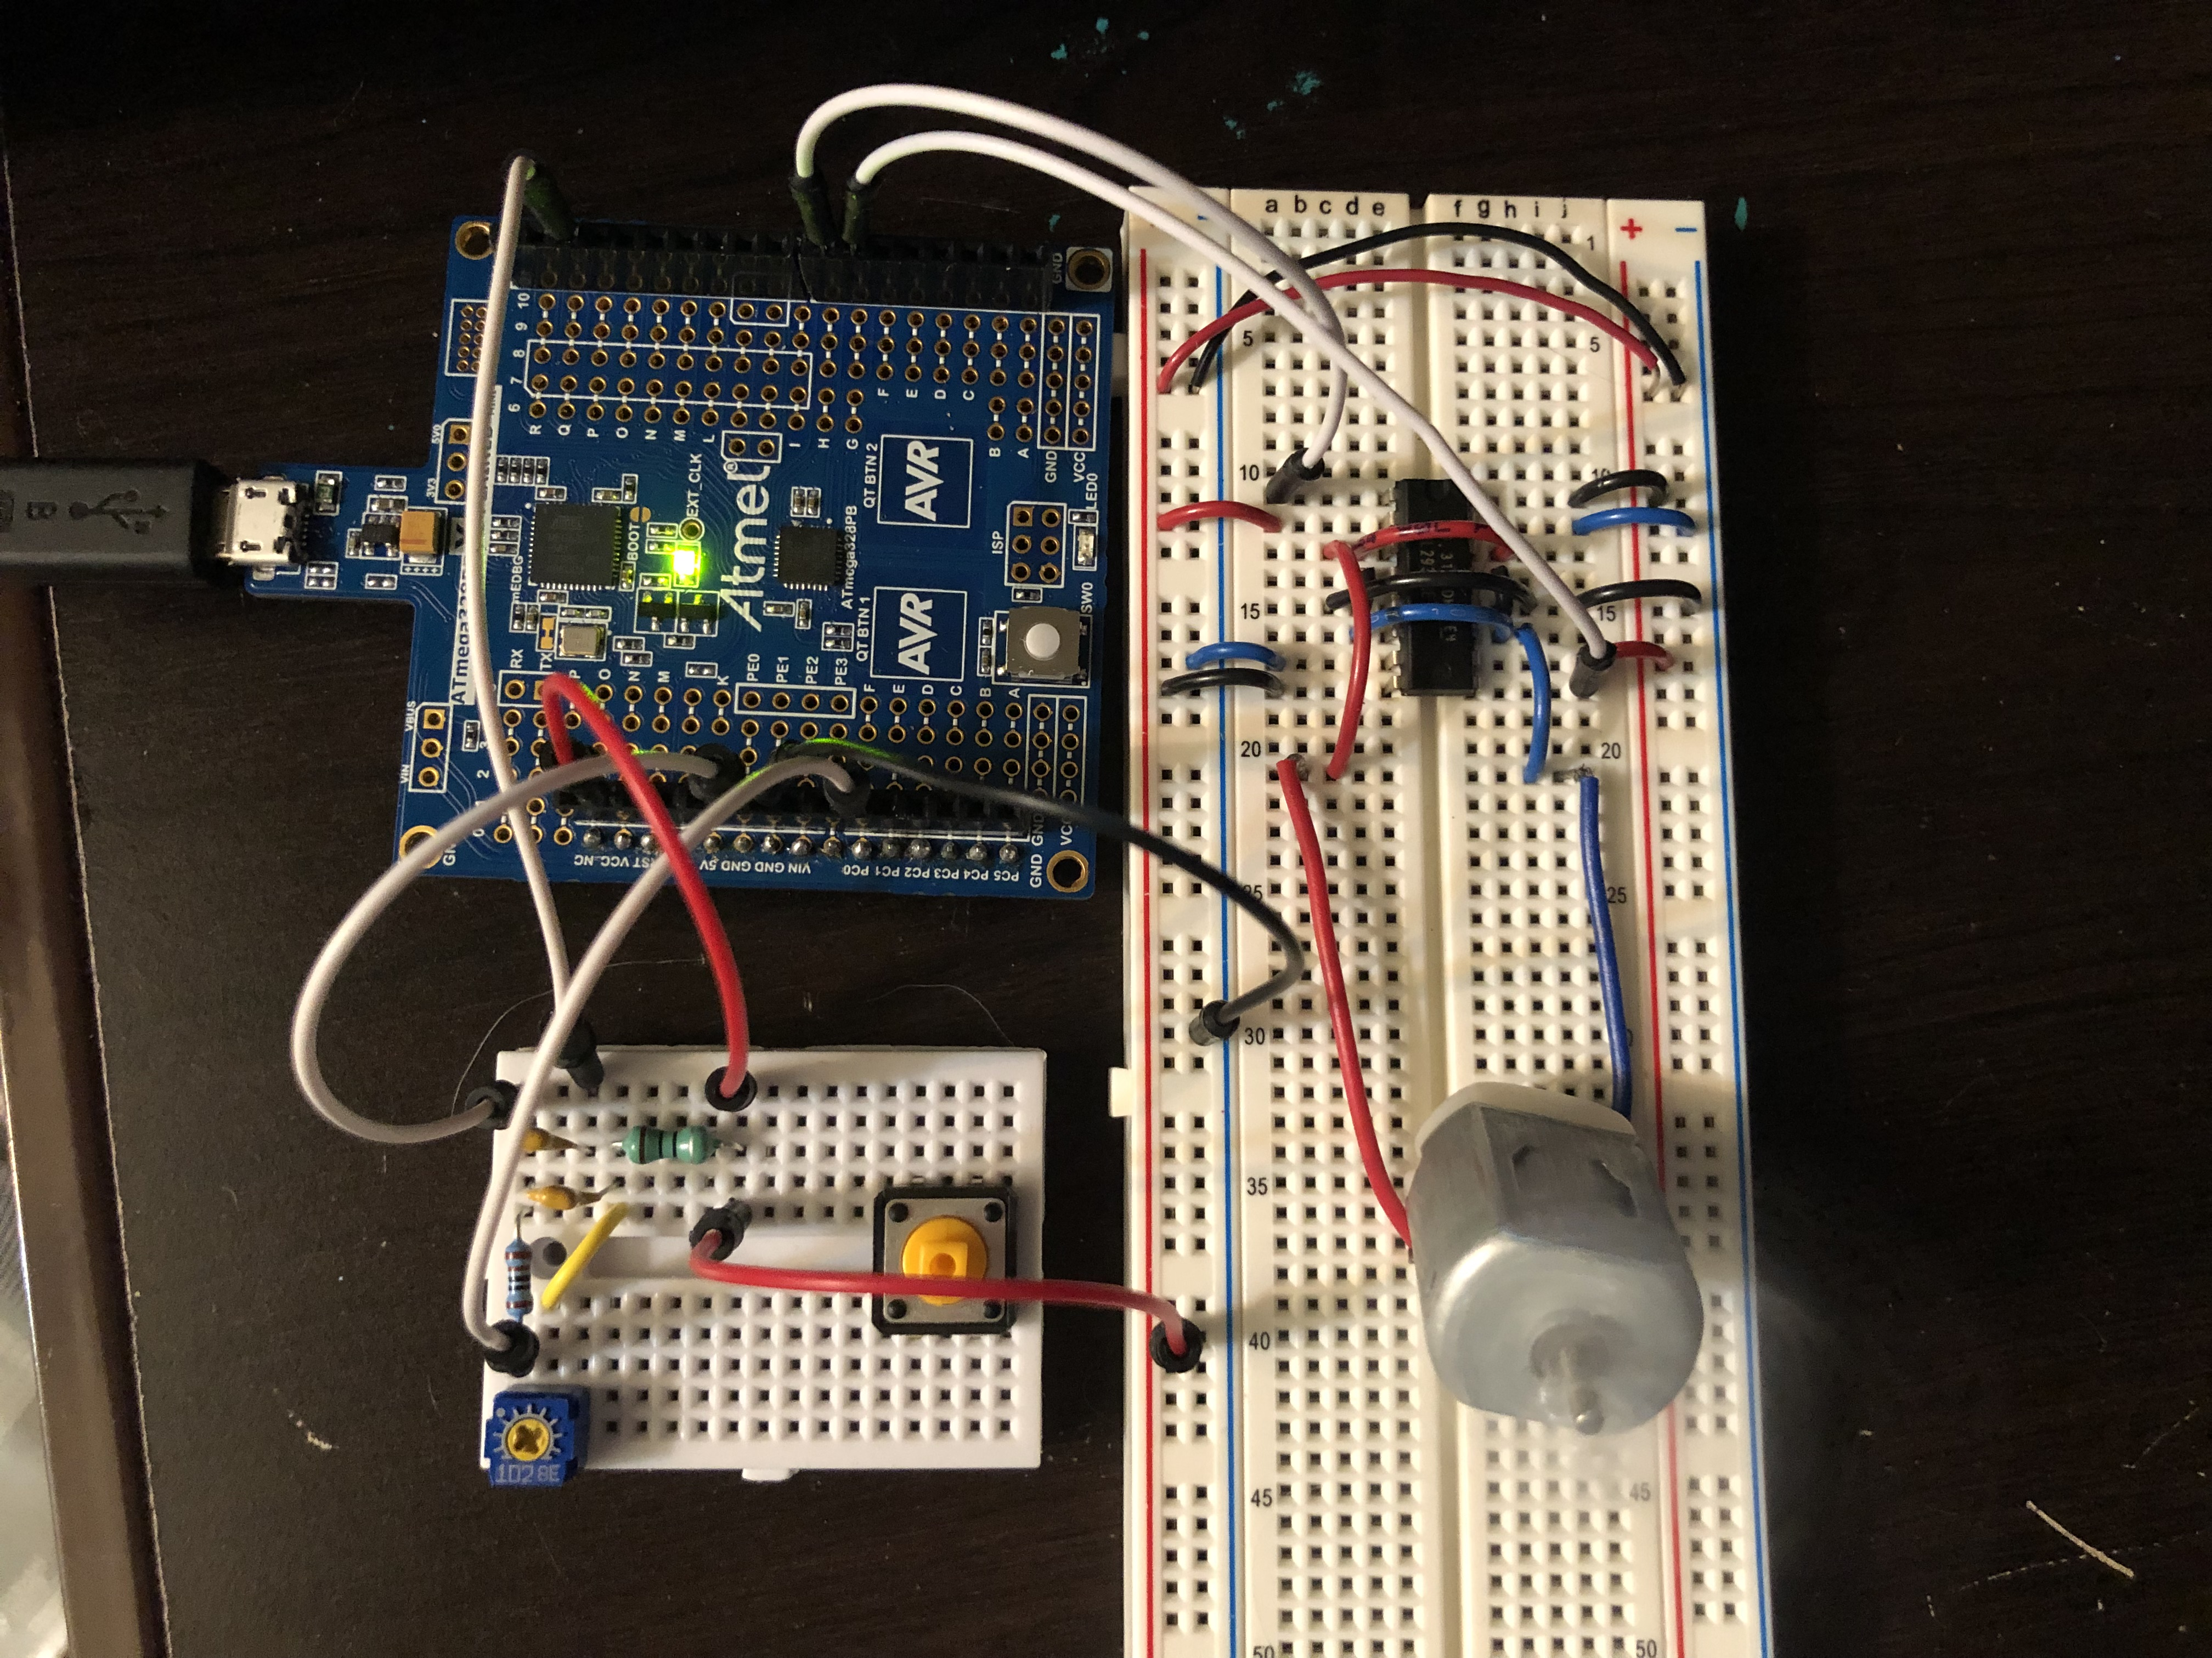

*Figure 5 – Xplained Mini connected to Potentiometer and DC Motor*

1. **VIDEO LINKS OF EACH DEMO**

https://youtu.be/KNZYYGoeRr4

1. **GITHUB LINK OF THIS DA**

https://github.com/rockyg1995/ihswppdar/tree/master/DesignAssignments/DA4A

**Student Academic Misconduct Policy**

<http://studentconduct.unlv.edu/misconduct/policy.html>

“This assignment submission is my own, original work”.

Rocky Gonzalez